Badminton:
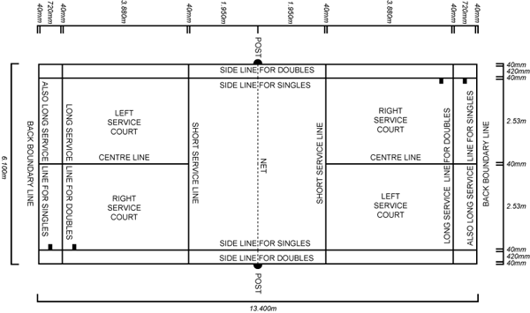
The Court
The court is rectangular and divided into halves by a net. The doubles court is wider than the singles court, but both are the same length.
The exception is that the doubles court has a shorter serve-length dimension.
The full width of the court is 20 ft, and in singles this width is reduced to 17 ft. The full length of the court is 44 ft.
In doubles, the service court is also marked by a long service line, which is 2 ft 6 inch from the baseline.
The net is 5 ft high. The net posts are placed over the doubles sidelines, even when singles is played.
In doubles play, the service court is short and wide (long service line and doubles side line respectively)
In singles play, the service court is long and slender (baseline and singles side line respectively)
Description
Badminton is a sport played by either two opposing players (singles) or two opposing pairs (doubles), who take positions on opposite halves of a rectangular court that is divided by a net.
Players score points by striking a shuttlecock (birdie) with their racquet so that it passes over the net and lands in their opponents' half of the court. Each side may only strike the shuttlecock once.

History
The game was called "Poona" in India during the 18th century, and British Army officers stationed there took a competitive Indian version back to England in the 1860s, where it was played at country houses as an upper class amusement.
The new sport was definitively launched in 1873 at the Badminton House, Gloucestershire, owned by the Duke of Beaufort. During that time, the game was referred to as "The Game of Badminton," and the game's official name became Badminton.
Types of Shots
Serve – This shot used to begin play. During the serve, the server’s feet must remain stationary; contact of the birdie must take place below the waist (with an underhand motion or backhand.)
Clear – This high deep shot is a defensive shot used to push the opponent to the rear of the court making it difficult to attack with the next short.
Drive – This is an attacking shot that is hit hard at a flat angle parallel to the floor. Drives take place from the midcourt or further and our usually angled to a deep corner of the opposing court or directly at an opposing player.
Smash – This shot is an attacking shot that is hit hard at a downward angle. Smashes take place from the midcourt or closer and our usually accompanied by a jump to help increase the downward angle of the shot.
Drop Shot – This short, low, and soft attacking shot from the backcourt and is used to attack the forecourt and is very effective when done with deception of other shots.
Net Drop Shot – short, low and soft attacking shot from one’s own frontcourt to opponents’ frontcourt.
Lob – from one’s frontcourt to opponents’ backcourt (an underhand shot has high trajectory). 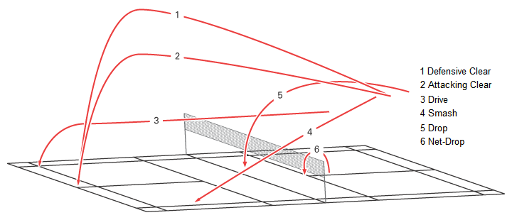
Serving
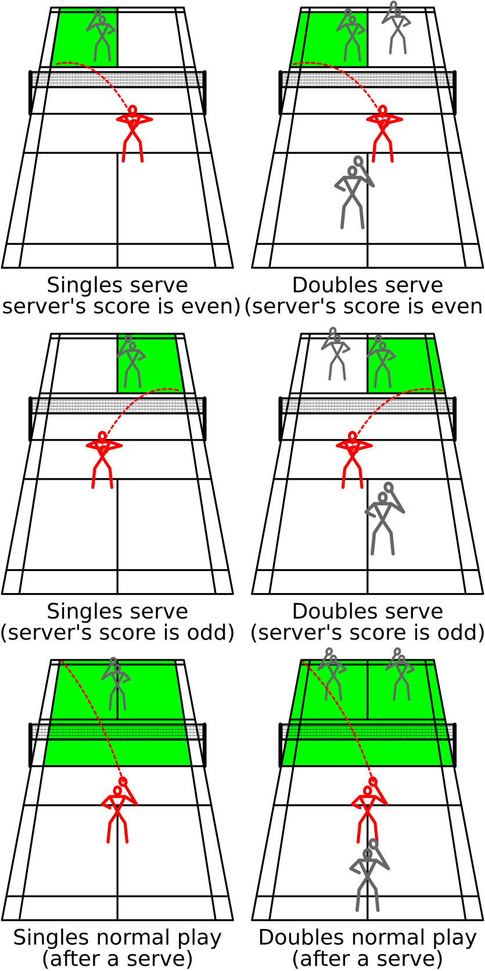

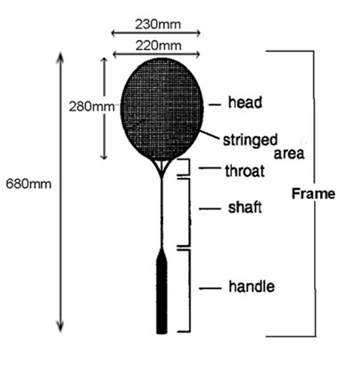

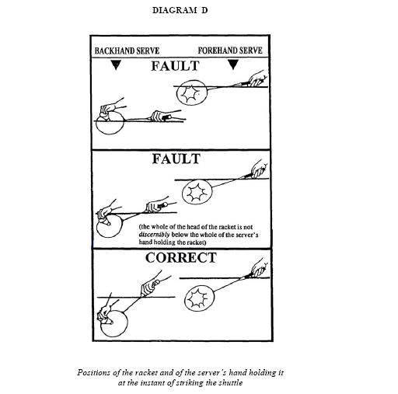
Faults
Players win a rally by striking the shuttlecock over the net and onto the floor within the boundaries of their opponents' court.
Players also win a rally if their opponents commit a fault (The most common fault in badminton is when the players fail to return the shuttlecock so that it passes over the net and lands inside their opponents' court, but there are also other ways that players may be faulted).
The following information lists some of the more common faults:
Several faults pertain specifically to service. A serving player shall be faulted if the shuttlecock is above his waist (defined as his lowest rib) at point of contact, or if his racket's head is not pointing downwards at the moment of impact.
Neither the server nor the receiver may lift a foot until the server has struck the shuttlecock.
Each side may only strike the shuttlecock once before it passes back over the net; but during a single stroke movement, a player may contact a shuttlecock twice (this happens in some sliced shots).
A player may not, however, hit the shuttlecock once and then hit it with a new movement, nor may he carry and sling the shuttlecock on his racket.
It is a fault if the shuttlecock hits the ceiling.
Lets
If a let is called, the rally is stopped and replayed with no change to the score. Lets may occur due to some unexpected disturbance such as a shuttlecock landing on court (having been hit there by players on an adjacent court)
If the receiver is not ready when the service is delivered, a let shall be called; yet if the receiver makes any attempt to return the shuttlecock, he shall be judged to have been ready.
There is NO let if the shuttlecock hits the tape (even on service).
Scoring: Rally System
- A match consists of the best of 3 games of 21 points.
- Every time there is a serve – there is a point scored.
- The side winning a rally adds a point to its score.
- At 20 all, the side which gains a 2 point lead first, wins that game.
- At 29 all, the side scoring the 30th point, wins that game.
- The side winning a game serves first in the next game.
Interval and Change of Ends
- When the leading score reaches 11 points, players have a 60 second interval.
- A 2 minute interval between each game is allowed.
- In the third game, players change ends when the leading score reaches 11 points.
Singles
- At the beginning of the game (0-0) and when the server’s score is even, the server serves from the right service court. When the server’s score is odd, the server serves from the left service court.
- If the server wins a rally, the server scores a point and then serves again from the alternate service court.
- If the receiver wins a rally, the receiver scores a point and becomes the new server. They serve from the appropriate service court – left if their score is odd, and right if it is even.
Doubles
- A side has only one ‘service’.
- The service passes consecutively to the players as shown in the diagram.
- At the beginning of the game and when the score is even, the server serves from the right service court. When it is odd, the server serves from the left court.
- If the serving side wins a rally, the serving side scores a point and the same server serves again from the alternate service court.
- If the receiving side wins a rally, the receiving side scores a point. The receiving side becomes the new serving side.
- The players do not change their respective service courts until they win a point when their side is serving.
If players commit an error in the service court, the error is corrected when the mistake is discovered.
BADMINTON: In a doubles match between A & B against C & D. A & B won the toss and decided to serve. A to serve to C. A shall be the initial server while C shall be the initial receiver.
Action Score Service Ct. Server & Receiver Winner
 | Love All | Right Service Court. Being the score of the serving side is even. | A serves to C A and C are the initial server and receiver. |  | 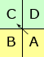 | A & B
A & B win a point. A & B will change service courts. A serves again from Left service court. C & D will stay in the same service courts. | 1-0 | Left Service Court. Being the score of the serving side is odd | A serves to D |  | 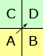 | C & D
C & D win a point and also right to serve. Nobody will change their respective service courts. | 1-1 | Left Service Court. Being the score of the serving side is odd. | D serves to A. |  | 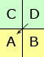 | A & B
A & B win a point and also right to serve. Nobody will change their respective service courts. | 2-1 | Right Service Court. Being the score of the serving side is even. | B serves to C |  | 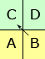 | C & D
C & D win a point and also right to serve. Nobody will change their respective service courts. | 2-2 | Right Service Court. Being the score of the serving side is even. | C serves to B |  | 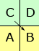 | C & D
C & D win a point. C & D will change service courts. C serves from Left service court. A & B will stay in the same service courts. | 3-2 | Left Service Court. Being the score of the serving side is odd. | C serves to A |  | 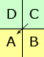 | A & B
A & B win a point and also right to serve. Nobody will change their respective service courts. | 3-3 | Left Service Court. Being the score of the serving side is odd. | A serves to C |  | 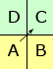 | A & B
A & B win a point. A & B will change service courts. A serves again from Right service court. C & D will stay in the same service courts. | 4-3 | Right Service Court. Being the score of the serving side is even. | A serves to D |  | 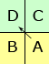 | C & D
- The order of server depends on the score odd or even same as in singles.
- The service courts are changed by the servicing side only when a point is scored. In all other cases, the players continue to stay in their respective service court from where they played previous rally. This shall guarantee alternate server.
