Flag Football
The Field
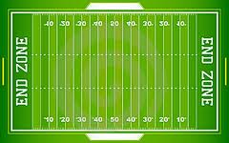

Area of grass or turf that measures 120 yards by 53.5 yards wide.

Each end zone is 10 yards long.

At both ends of the field there are white lines called goal lines that mark off the entrances to the end zones.

The lines that run down the length of the field where the ball is placed on or in between to start a play are called the hash marks.

The line of scrimmage is an imaginary line that runs parallel to the end zone which players cannot cross until the ball is hiked.

If an offensive player crosses the line of scrimmage before the ball is hiked it is termed false start.

If a defensive player crosses the line of scrimmage before the ball is hiked it is termed off sides.

Goal posts are located at each end of the field and measure 10 feet high and 23 feet 4 inches wide.

Pylon markers are included on the field of play located at the front and far corners of each end zone.

If a player steps on the sideline, he is considered to be out of play.

Positions

Quarterback: person who calls the plays and throws or hands the ball to another player

Center: person who snaps the ball to the quarterback and is an ineligible receiver

Fullback: person who stands behind or next to the quarter back and can run the ball

Receiver: person who runs various routes to allow for a pass to be caught

Cornerback: defensive person who covers a receiver to prevent the receiver from catching the ball

Defensive end: defensive player who contains the running back on running plays and pressures the quarterback

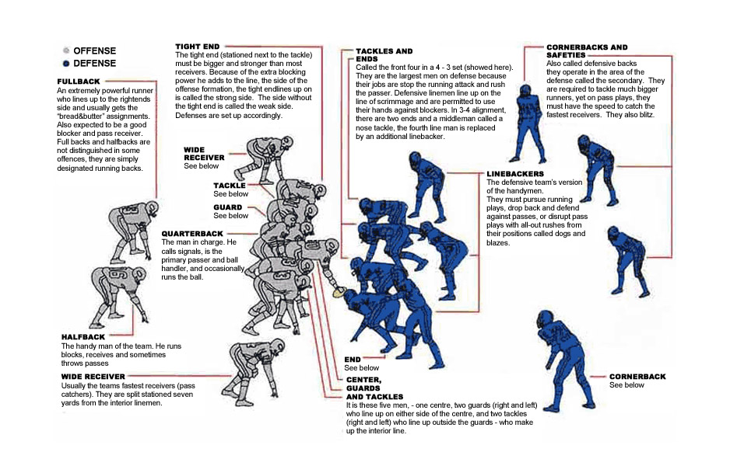
Nose tackle: defensive player who lines up directly across from the center who pressures the line and helps stop the run

Terms

Advance: Moving the ball down field by either a pass or a run.

Blocking : Obstructing the path of the opponent by use of the blocker's body.
Forearms must be against the blocker's body and the blocker's feet MAY NOT LEAVE THE GROUND at any time. The opponent may NOT RUN INTO (cause personal contact) a blocker.

Conversion (P.A.T)—An attempt for an extra point following a touchdown. The scoring team is given one play from the ten yard line to complete a pass or to run the ball over the goal line.

Defense: The team that does not have the ball. The defensive team must be three (3) feet away from the line of scrimmage when the ball is hiked.

Down: A unit of the game which starts with the centering of the ball and ends when the ball is ruled dead. This is an attempt by the offensive team to advance the ball. The offensive team has four attempts (downs) to successfully advance the ball to score. If the offensive team fails to do this, possession of the ball goes to the defensive team.

End Zone: Area of the playing field between the goal line and the end line.

Flag Guarding: Any player using hands, arms, clothing or spinning to prevent a player
from pulling the flag. This is a foul.

Forward Pass: A forward pass may be made from any point behind the line of
scrimmage to any player on the offensive team. If the pass is intercepted by the defense, the defense gains possession and may run with the ball until stopped, at which point it becomes the first down for the team that made the interception.

Fumbled Ball: A ball, touching a player or being held by a player that falls on the ground, is DEAD at the spot where it first touches the ground. The ball remains with the team that fumbled and a down is counted against them.

Incomplete Pass: A legal pass which hits the ground before it is caught by either team. The ball is brought back to the spot of the previous snap and a DOWN is counted against them.

Line of Scrimmage—An imaginary line across the field at the point where the ball is to
be put into play (runs side-line to side-line and parallel to the goal line)

Offense: The team in possession of the ball. The offensive team must be behind the line of scrimmage until the ball is snapped.

Off-Side: The defensive team enters the NEUTRAL ZONE or crosses the line of scrimmage before the ball is snapped.

Neutral Zone: A three foot area separating the defensive team from the line of scrimmage until the ball is centered.

Pass Interference: A player interfering with another player who is trying to catch a pass. The ball is awarded to the team fouled at the spot where the foul occurred.

Safety: When the offensive team is caught (downed) in their own end-zone WITH the ball. The ball is brought to the quarter line for a kick-off by the team scored against. The other team gets two points and receives the kick-off.

Touchdown: Running or passing the ball across the goal line. Six (6) points are awarded. The ball is put into play, following the touchdown and the conversion play (P.A.T.) with a kick-off by the scoring team.

How to play Flag Football

To maintain possession, the offensive team has four attempts (plays) to successfully advance the ball. They have four chances to get two complete passes. If the offensive team fails to do this, possession of the ball goes over to the defensive team.

A. Start the game with a place kick (kick-off) from the quarter line. No player may cross their quarter line until the ball has been kicked. This applies to both teams. When a kick-off is caught or picked up and carried, the ball may be handed off, run, or lateraled. The ball remains in play until the ball carrier's flag is pulled at which point the Line of Scrimmage is established. If the kick-off is fumbled, the ball is dead at the spot where it first touched the ground after touching a player.

B. Flags are to be worn by all players. When the flag is pulled from the belt of the ball carrier, the play stops. The next play will begin at that point.

C. Balls kicked or run out of bounds on the sideline are placed on the line of scrimmage determined where the ball went out.

D. Following a kick, if a member of the kicking team touches the ball before it has been touched by a member of the receiving team, it is dead and the next play will begin at that spot.

E. All fouls and infractions of game rules are penalized in the following manner:
A foul by the OFFENSIVE team is a loss of a down.
A foul by the DEFENSIVE team is a down gained by the offense.

LOSS OR GAIN OF A DOWN would occur following any foul or infraction listed:
1. Pushing and shoving (any personal contact).
2. Delay of the game (more than 20 seconds in huddle).
3. Center running with the ball instead of hiking back to a fielder.
4. Forward pass in front of the line of scrimmage.
5. Pass interference.
6. Off-sides on the kick or during scrimmage play.
7. Rushing on the declared punt---or not declaring a punt.
8. Flag guarding, or running with the ball without wearing a flag.
9. Unsportsmanlike conduct---Abusive or insulting language.

F. SCORING:
(1) Touchdown---6 points
(2) Conversion (P.A.T.)---1 point for running, 2 for passing
(3) Safety---2 points

G. The ball is DEAD:
1. On fumbles
2. Touchback (when ball is kicked or intercepted in the end zone).
3. When the carrier's flag is pulled ("tackled").
4. Incomplete forward pass (return ball to last spot).
5. Ball run, kicked, or thrown out of bounds (comes in 5 yards).
6. When the ball carrier falls (ball is down on the spot).
7. After a touchdown, conversion, safety.
8. When a player on the kicking team touches the ball before the receiving team.

