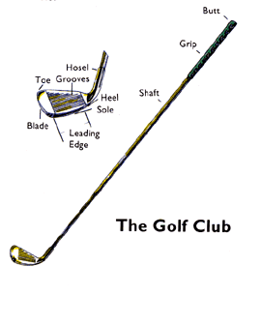
Golf Study Guide
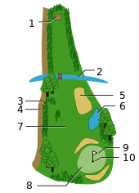
Golf course features:
1 = teeing ground
2 = water hazard
3 = rough
4 = out of bounds
5 = bunker
6 = water hazard
7 = fairway
8 = putting green
9 = pin
10 = hole

A typical golf course has 18 holes. The front nine (Hole 1-9)and the back nine (10-18). It is made up of a combination of par 3’s, 4’s, and 5’s. The par of a typical golf course is 72 strokes.

Bunker: An obstacle placed on the fairway or around the green filled with sand (sand trap).
Rough: The unkept territory surrounding the fairway or green.
Fairway: Safest location to play from, this grass is trimmed down for good contact.
Green: Location designated as the target area for each hole (nice groomed grass).

Grips: 1. Interlocking 2. Overlapping 3. Baseball
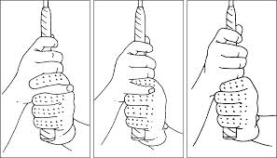

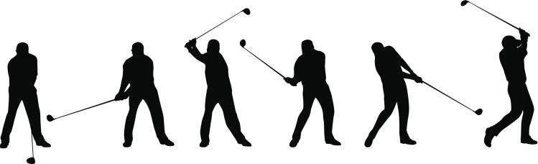

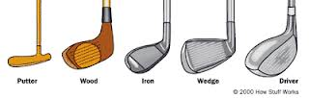
Types of Clubs:
A driver, usually numbered a 1-wood regardless of actual loft, which varies from 8° up to 13°
A fairway wood, typically numbered a 3-wood and lofted about 15° (though 2- and 4-woods are sometimes seen)
A matched set of 7 numbered irons from 3 through 9, plus a pitching wedge or "10-iron"
A sand wedge
A putter

Hole in one: The ball goes in the hole in one stroke.

Eagle: Two under par

Birdie: One under par

Bogey: One over par

Double bogey: Two over par

Score: The number of shots for each hole totaled.

Honor: The privilege of playing first, acquired by winning the preceding hole.

Caddie: A person other than the player who carries the golf bag for a player.

Divot: piece of turf removed by the club while taking a shot

Slice: the flight of the ball curves to the right

Hook: the flight of the ball curves to the left

Tee: A small wooden peg which the ball rests. Only used on the first shot.

Golf began in the early 1400’s in Scotland. The original ball was made of wood and soon evolved to leather and filled with feathers. In the 1850’s the “Gutta Percha” ball was invented made from gutta percha trees in India. The gutta percha was boiled and then shaped into balls. In 1901, the rubber-core Haskell Ball was invented. They are still today made of resin and rubber.

