Soccer Study Guide
Rules of the Game:
- The field of play must be a rectangle 100-130 yards in length, 50-100 yards in width.
- Each team has 11 players one of whom must be the goalkeeper.
- At the start of play each team must be in its own half of the field, the team not kicking must be 10 yards from the ball until the ball is in play. After a goal, the team scored upon must kick off.
- The ball is in play until it has wholly crossed the goal or touchline. When the ball goes over the touchline it results in a throw in. The ball goes to the opposite team of whoever last touched the ball before it went out. On a throw in both feet must remain in contact with the ground. Both hands must be used and the ball must be thrown directly overhead.
- When the ball goes across the end line 3 things can occur.
  - A Goal is scored when the entire ball crosses the whole line in the goal area.
  - Corner Kick the ball is hit out by a defensive player. Other tem receives a free kick from the corner of the field.
  - Goal Kick the ball is hit out by an offensive player. Defending team receives a free kick from within penalty are (18 yard line).
- When the ball changes possession it is called a turnover.
- Fouls and Misconducts:
  - Direct Free Kick results from more obvious and intentional fouls (tripping & pushing).
  - Indirect Kick results from fouls such as off-sides, unintentional ball handling. The ball is placed where the mishap occurred and a goal cannot be scored unless the ball is first touched by another player other than the kicker.
  - Penalty Kick direct violation which occurs inside the penalty area. The ball is placed on the 12 yard line and a direct kick results, one on one with the goalkeeper.
- Off-sides you cannot be off-sides on a throw in. You can never be off-sides on your own side of the field. Off-sides depends on where the ball is and where the players are. The rule states that an offensive player cannot be in advance of the ball unless there are 2 opponents between him and the goal. If the ball is in front of you, you cannot be off-sides. What counts is where you are the off-sides penalty results in an indirect free kick for the other team.
- Yellow Card is presented to a player for unsportsmanlike conduct. This means possible ejection from the game.
- Red Card presented to a player means ejection from the game.
Skills:
- Trapping – a method of receiving the ball and controlling the ball.
- Heading – all players may hit the ball off of the center of their forehead to move, pass, score and control the game.
- Dribbling – a method of moving the ball down the field by using a series of short, controlled kicks.
- Clear – used primarily by the defense to move the ball from one end of the field to the other end.
- Cross – Strategy of moving the ball from one side of the field to the other end.
- Passing – used to send the ball from one teammate to another.
- Shooting – used to attempt to score on the goalie.
Midfield line: Line that divides the field into equal halves.
Touch Line: The line that defines the outer edge of the longer sides of the field. When the ball goes out of bounds over the touch line, a throw in occurs. Also called the sideline.
Goal lines: Lines that mark out of bounds at either end of the field. When the ball goes out of bounds over the goal line, either a goal kick or corner kick occurs, depending on which team last touched the ball. Also called end lines.
Penalty area: Arguably the most important portion of the field, because a foul inside the penalty area results in a penalty kick. Also called the penalty box.
Goal area: Goal kicks are taken from the corners of this box.
Goal: Points are scored when the ball passes through the 8-foot tall goal.
Center circle: Opposing players must stand outside the circle until the ball is kicked to initiate the game in a kickoff.
Center spot: A mark at the center of the halfway line where the ball is placed during kickoffs.
Corner kick quarter-circles: Area where ball is placed on corner kicks. A flag at least five feet high stands at all four corners.
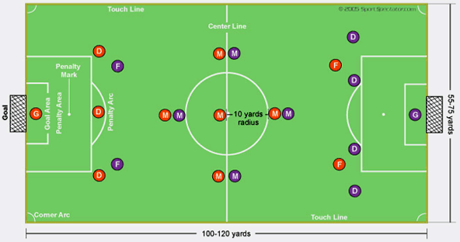Positions
Players are divided into two basic classifications: goalkeepers and field players. Field players consist of forwards, midfielders and fullbacks. Coaches can mix and match the number of players at each position, as long as there are 11 players on the field. Sample formations include 4-4-2, 3-5-2, 4-2-4, etc. and are listed fullback-midfielder-forward, respectively (see diagram).
Positions
Goalkeeper: Keeps the ball out of the goal and organizes team defense. Uses hands and arms within the penalty area. Possesses sure hands to catch, deflect, or punch shots away from the goal. Also called goalie or keeper.
Forwards: Attack the opposition to create scoring opportunities. Take the majority of shots. Also called attackers.
Midfielders: Enable the transition from the fullbacks to the forward. Constantly in motion, both defending and attacking. Also called halfbacks.
Fullbacks: Provide last line of defense before the goalie. Stop the opposition before a shot is taken. Some coaches assign a single defender, called a sweeper, who plays closest to his own goal behind the fullbacks.

