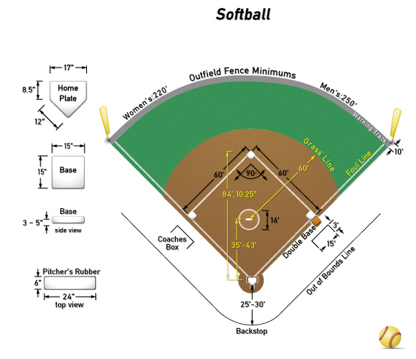

The Field
Softball is played on a large grass and dirt field. The field includes fair territory inside the two foul lines and foul territory outside the foul lines.
Bases: A softball “diamond” consists of four bases placed in a square. The bases are 1st base, 2nd base, 3rd base, and home plate. Bases are 60 feet apart.
Infield: The area around the four bases, the surface of which is generally packed dirt.
Outfield: The grassy area beyond the infield.
Foul lines: Two lines (first and third base line) that distinguish fair territory from foul territory. A ball that hits the foul line is called fair.
Foul poles: Poles stationed at the end of each foul line to distinguish fair territory from foul territory for balls hit over the outfield fence. A ball that hits the foul pole is a home run.
Pitcher’s mound: The area in the middle of the diamond from which the pitcher throws the ball.
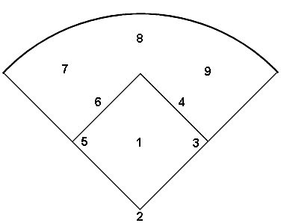
Infielders
Pitcher: (1) Pitches the ball from the pitcher’s mound to the catcher.
Catcher: (2) Crouches behind home plate and receives pitches thrown by the pitcher. Also receives throws from fielders attempting to make outs at home plate.
First baseman: (3) “Fields,” or defends, balls hit near the 1st base line. Receives throws from fielders attempting to make outs at 1st base.
Second baseman: (4) Fields balls hit near 2nd base. Receives throws from fielders attempting to make outs at 2nd base. Often involved in a double-play. Usually the cut off to home plate from right field.
Third baseman: (5)Fields balls hit near the 3rd base line. Receives throws from other fielders attempting to make outs at 3rd base.
Shortstop: (6) Fields balls hit between second base and the third baseman. Covers 2nd base when the ball is hit to the second baseman. Usually the cut off to home plate from the outfield (Left and Center)
Outfielders
Three outfielders — (7) left fielder, (8)center fielderand (9) right fielder— attempt to catch balls hit into their portion of the outfield. Balls hit to the outfield are generally ground balls or fly balls hit past the infield.

Terms:
Batter: the offensive person who attempts to hit the ball and has the goal of reaching each base safely to score a run
Pitcher: defensive player who delivers the ball to the batter
Strike: a pitch that is in the strike zone that is swung at and missed or not swung at
Ball: a pitch that is out of the strike zone
Inning: divided into the top (visiting team hits) and bottom (home team hits), consists of 3 outs per team
Batter’s box: the area designated on either side of home plate for the batter to stand in when hitting the ball
Double play: a play where the defense records two outs from one batted ball
Error: Charged to a defensive player for mistakes that should have resulted in an out.
Foul ball: A batted ball that lands in foul territory or rolls into foul territory before reaching first or third base.
Pop up: a ball that is batted into the air
Line Drive: a ball that is hit hard in the air and parallel to the ground
Grounder: a ball that is batted and hits the ground in fair territory
Strike zone: an area designated for a batter to hit a ball
Walk: a free base is awarded to the batter after being pitched 4 balls that were not in the strike zone
Glove: worn on the non- throwing hand to catch the ball
Infielder: defensive player playing in the infield, pitcher (1), catcher (2), first (3), second (4), third (5), shortstop (6)
Outfielder: defensive player in left (7), center (8), or right field (9)
On deck: the next batter
Force out: After a batter hits the ball, the batter/runner must advance to 1st base. The defense can get her/him out by throwing the fielded ball to 1st base before the runner reaches the base. Additionally, other base runners must advance if they are forced by a base runner behind them. A runner has to advance to the next base to make room for the following base runner.
Run: Scored when an offensive player safely tags home plate.
Tag up: A player waits for a fly ball to be caught before advancing to the next base or else the defense can throw the ball to the base that the runner was on before she can return to it and record another out.
How to play the game of softball:
There are 9 players on the field/up to bat on each team. Games will consist of 7 innings and each team is given 3 outs per inning. The team that scores the most runs (batters that cross home plate) after 7 complete innings wins the game. There is no time limit in the game of softball.
The playing field is divided into the infield (usually all dirt) and the outfield (grass).
Bases are 60 feet apart and the pitcher’s mound is 43 feet from the back point of home plate.
The pitcher must deliver the ball underhand.
The batting order is designated at the beginning of the game and does not change throughout the game. The batter must be standing in the batter’s box .
The batter/runner is out when:
- 3 strikes have been called,
- a fly ball or ball that is batted and does not touch the ground is caught by a defensive player
- ground ball is hit and a defensive player throws it to the base the batter is running to and it is caught by another defensive player prior to the runner reaching the base
- a defensive player touches the base with glove or foot that a runner is forced to run to
- a runner is hit by a batted ball
- a runner interferes with a defensive player making an attempt to field the ball
- a runner is tagged by a defensive player with possession of the ball
- a runner leaves the base early prior to the ball being released by the pitcher
- a runner overruns second base or third base and is tagged
- a runner does not touch a base and the defensive team appeals
- a runner runs more than 3 feet out of the baseline to avoid being tagged

A team will score a run when a runner crosses home plate before the third out of the inning.
To score an offensive play, a batter will hit a single (reached 1st base safely), a double (reached second base safely), a triple (reached 3rd base safely) or a homerun (reached home safely).
A batter will receive a BB or base on balls if four pitches were not called strikes during his/her at bat.
If a ball is hit to a defensive player who makes an error, the batter does not get credit for a hit, but will still continue to run the bases.
When recording a defensive play, use the proper numbers of the positions. For example if the ball was hit to the shortstop who threw it to first base for the out, it would be recorded as 6-3.
6 (the shortstop) would get credit for the assist and 3 (the first baseman) would get credit for the putout.
A double play ball hit to the shortstop, thrown to the second baseman who then throws to the first baseman would be scored as 6-4-3.

