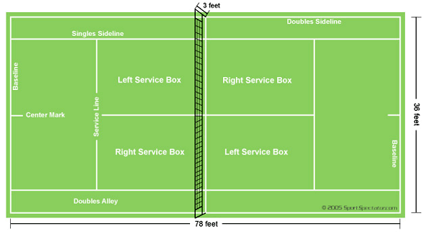
Tennis
The Court
Tennis is played on a rectangular, flat surface, usually grass, clay, or a hard court of concrete and/or asphalt.
The court is 78 feet long, and its width is 27 feet for singles matches and 36 ft for doubles matches.
The net is 3 feet 6 inches high at the posts and 3 feet high in the center.
The lines that delineate the width of the court are called the baseline (farthest back) and the service line (middle of the court).
The short mark in the center of each baseline is referred to as either the hash mark or the center mark.
The outermost lines that make up the length are called the doubles sidelines. These are the boundaries used when doubles is being played.
The lines to the inside of the doubles sidelines are the singles sidelines and are used as boundaries in singles play.
The area between a doubles sideline and the nearest singles sideline is called the doubles alley, which is considered playable in doubles play.
The line that runs across the center of a player's side of the court is called the service line because the serve must be delivered into the area between the service line and the net on the receiving side. Despite its name, this is not where a player legally stands when making a serve.
The line dividing the service line in two is called the centerline or center service line.
The boxes this centerline creates are called the service boxes; depending on a player's position, he will have to hit the ball into one of these when serving.
A ball is out only if none of it has hit the line upon its first bounce.

How to play the game of tennis
The players (or teams) start on opposite sides of the net.
One player is designated the server for the entire game, and the opposing player, or in doubles one of the opposing players, is the receiver.
Service alternates between the two halves of the court.
For each point, the server starts behind his baseline, between the center mark and the sideline.
The receiver may start anywhere on their side of the net.
In a legal service, the ball travels over the net (without touching it) and into the diagonally opposite service box.
If the ball hits the net but lands in the service box, this is a let or net service, which is void, and the server gets to retake that serve.
The player can serve any number of let services in a point and they are always treated as voids and not as faults.
A fault is a serve that is long, wide, or not over the net.
There is also a "foot fault", which occurs when a player's foot touches the baseline or an extension of the center mark before the ball is hit. If the second service is also faulty, this is a double fault, and the receiver wins the point.
However, if the serve is in, it is considered a legal service.
A legal service starts a rally, in which the players alternate hitting the ball across the net.
A legal return consists of the player or team hitting the ball exactly once before it has bounced twice or hit any fixtures except the net, provided that it still falls in the server's court.
The ball then travels back over the net and bounces in the court on the opposite side. The first player or team to fail to make a legal return loses the rally.
A ball that hits the line is to be considered good.

Scoring:
One person serves the entire game.
The server must always say the score prior to serving saying the server’s score first, then the opponents.
Zero points = Love
1 point = 15
2 points = 30
3 points = 40
4 points = game
If the score is tied 40-40 it is called deuce. At deuce, a player must win by two points. If the server wins the next point (after deuce) it is called advantage in. If the opponent wins the next point (after deuce), it is called advantage out.
The serving order for doubles is the following:

Team 1 has A and B as partners and Team 2 had C and D as partners:
• A or B serve the first game
• C or D serve the second game.
• The player from team 1 who didn't serve, serves the third game.
• The player from team 2 who didn't serve, serves the fourth game.
• The teams must keep the same service order for each set.
After the game, the opponents serve. Games equal 1. The first to win 6 games, by two, wins the set. The first to win 2 sets wins the match. If the score is 6-6, a tie-breaker is played. This is scored by one's. The first team to score 7 points winning by two wins the set. The tiebreaker continues until one side wins by two. Points win games. Games win sets. Sets win matches. Hence, Game-Set-Match.
History
Sometime in between the 11th and 12th centuries, French monks started playing a game using just their hands and a crude ball made up of cork or wool wrapped in cloth or leather. They would either hit the ball off the monastery wall or over a single piece of rope strung across a courtyard. They named the game "Jeu de Paume”, which means "game of the hand." By the 13th century, with ever increasing popularity, came changes and improvements to the game. Since striking the ball with the hand tended to be a bit painful, a glove with webbing or a solid paddle with handle started being used, the first introduction of the racquet. In 1874, Major Walter Wingfield patented the equipment and the rules of tennis that we are familiar with today. Three years later the first Wimbledon was played, and from that point on it was known as "lawn tennis" in England and "court tennis" in the United States.

Tennis Terms:
Ace: winning serve that is untouched
Alley: The area on the sides of the court used in doubles play. Any ball that lands in this area is considered good and must be played. Exception: this area is considered out on a serve and singles play.
Backhand: stroke used to hit a ball that comes to the non-racquet side of your body
Fault: a service that is not good
Double Fault: For each point, a server is allowed two attempts to serve the ball into the proper court. If both serves are “no good”, a double fault is called.
Doubles: A game played two vs. two
Forehand: stroke used to hit a ball that comes to the racquet side of your body
Let: A serve that hits the top of the net and goes into the proper court. It is re-taken without a penalty.
Lob: An upward stroke that sends the ball high and deep into the back court
Love: No score or a score of zero
Match: 2 out of 3 sets
Service Court: (see area on diagram) The server begins play from the right service court and serves from behind his baseline to his opponent’s right service court. The next point is served from the left service court to the opponent’s left and so on, alternately, throughout the game.
Set: The first player to win 6 games, but must win by two. At 6-6 a tie breaker is played.
Singles: A game played one vs. one
Game Point: A game point in tennis is when the server is one point away from winning the game.
Set Point: A set point in tennis is when one player is one point away from winning the game and the set.
Match Point: A match point in tennis is when one player is one point away from winning the game

